**SQL ASSIGNMENTS**

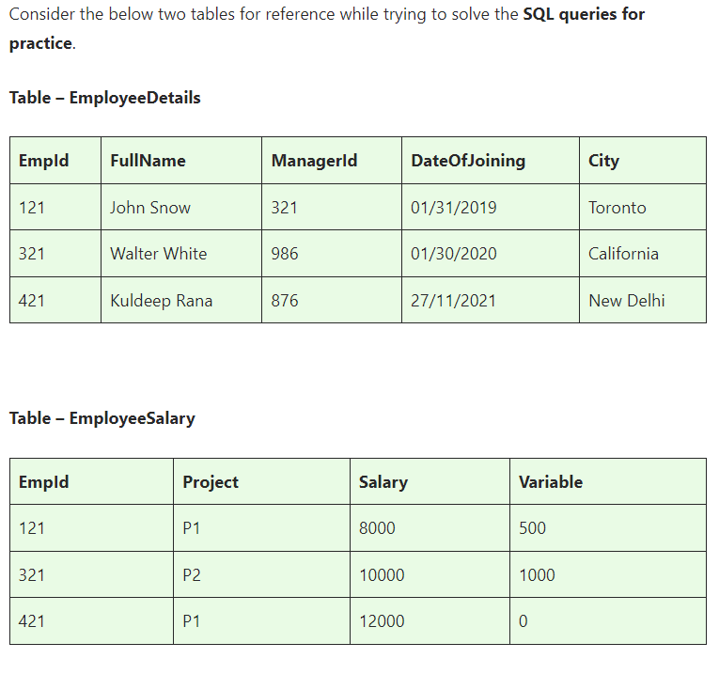

**Basics and Intermediate ASSINGMENT**

**ASSINGMENT nos - 1**

**Q1)SQL Query to fetch records that are present in one table but not in another table.**

**Answer-**

SELECT *

FROM EmployeeDetails

WHERE ManagerId NOT IN (SELECT Variable FROM EmployeeSalary)

**Q2)SQL query to fetch all the employees who are not working on any project.**

**Answer-**

Select *

FROM EmployeeDetails

LEFT JOIN EmployeeSalary ON EmployeeDetails.EmpId = EmployeeSalary.EmpId

WHERE EmployeeSalary.EmpId IS NULL

**Q3)SQL query to fetch all the Employees from EmployeeDetails who joined in the Year 2020.**

**Answer-** SELECT *

FROM EmployeeDetails

WHERE YEAR(DateofJoining) = 2020

**Q4)Fetch all employees from EmployeeDetails who have a salary record in EmployeeSalary.**

**Answer-** SELECT EmployeeDetails.*

FROM EmployeeDetails

INNER JOIN EmployeeSalary ON EmployeeDetails.EmpId = EmployeeSalary.EmpId

**Q5)Write an SQL query to fetch a project-wise count of employees.**

**Answer-** SELECT Project, COUNT(*) AS EmployeeCount

FROM EmployeeSalary

GROUP BY Project

**Q6)Fetch employee names and salaries even if the salary value is not present for the employee.**

**Answer-** SELECT EmployeeDetails.Fullname, COALESCE(EmployeeSalary.Salary, 'Salary not available') AS Salary

FROM EmployeeDetails

LEFT JOIN EmployeeSalary ON EmployeeDetails.EmpId = EmployeeSalary.EmpId

**Q7)Write an SQL query to fetch all the Employees who are also managers.**

**Answer-** SELECT e1.*

FROM EmployeeDetails e1

JOIN EmployeeDetails e2 ON e1.EmpId = e2.ManagerId

**Q8)Write an SQL query to fetch duplicate records from EmployeeDetails.**

**Answer-** SELECT EmpId, Fullname, COUNT(*) AS DuplicateCount

FROM EmployeeDetails

GROUP BY EmpId, Fullname

HAVING COUNT(*) > 1

**Q9)Write an SQL query to fetch only odd rows from the table.**

**Answer-** SELECT *

FROM (

SELECT *, ROW_NUMBER() OVER (ORDER BY <ordering_column>) AS rn

FROM EmployeeSalary

) AS subquery % 2 <> 0

**Q10)Write a query to find the 3rd highest salary from a table without top or limit keyword.**

**Answer-** SELECT Salary

FROM (

SELECT Salary, ROW_NUMBER() OVER (ORDER BY Salary DESC) AS rn

FROM EmployeeSalary

) AS subquery

WHERE rn = 3

**ASSINGMENT nos - 2**

**Ques.1. Write an SQL query to fetch the EmpId and FullName of all the employees working under the Manager with id – ‘986’.**

**Answer-** SELECT EmpId, FullName

FROM EmployeeDetails

WHERE ManagerId = 986

**Ques.2. Write an SQL query to fetch the different projects available from the EmployeeSalary table.**

**Answer-**

SELECT DISTINCT Project

FROM EmployeeSalary

**Ques.3. Write an SQL query to fetch the count of employees working in project ‘P1’.**

**Answer-** SELECT COUNT(*) AS EmployeeCount

FROM EmployeeSalary

WHERE Project = 'P1'

**Ques.4. Write an SQL query to find the maximum, minimum, and average salary of the employees.**

**Answer-** SELECT

MAX(Salary) AS MaxSalary,

MIN(Salary) AS MinSalary,

AVG(Salary) AS AvgSalary

FROM EmployeeSalary

**Ques.5. Write an SQL query to find the employee id whose salary lies in the range of 9000 and 15000.**

**Answer-**

SELECT EmpId

FROM EmployeeSalary

WHERE Salary BETWEEN 9000 AND 15000

**Ques.6. Write an SQL query to fetch those employees who live in Toronto and work under the manager with ManagerId – 321.**

**Answer-** SELECT *

FROM EmployeeDetails

WHERE City = 'Toronto' AND ManagerId = 321

**Ques.7. Write an SQL query to** f**etch all the employees who either live in California or work under a manager with ManagerId – 321.**

**Answer-** SELECT *

FROM EmployeeDetails

WHERE City = 'California' OR ManagerId = 321

**Ques.8. Write an SQL query to fetch all those employees who work on Projects other than P1.**

**Answer-** SELECT *

FROM EmployeeSalary

WHERE Project <> 'P1'

**Ques.9. Write an SQL query to display the total salary of each employee adding the Salary with Variable value.**

**Answer-** SELECT EmpId, SUM(Salary + Variable) AS TotalSalary

FROM EmployeeSalary

GROUP BY EmpId

**Ques.10. Write an SQL query to fetch the employees whose name begins with any two characters, followed by a text “hn” and ends with any sequence of characters.**

**Answer-** SELECT *

FROM EmployeeDetails

WHERE FullName LIKE '__hn%'

**ASSINGMENT nos - 3**

**Ques.1 Write an SQL query to fetch all the EmpIds which are present in either of the tables – ‘EmployeeDetails’ and ‘EmployeeSalary’.**

**Answer-** SELECT EmpId FROM EmployeeDetails

UNION

SELECT EmpId FROM EmployeeSalary

**Ques.2 Write an SQL query to fetch common records between two tables.**

**Answer-** SELECT *

FROM EmployeeDetails

INNER JOIN EmployeeSalary ON EmployeeDetails.EmpID = EmployeeSalary.EmpId

**Ques.3. Write an SQL query to fetch records that are present in one table but not in another table.**

SELECT *

FROM EmployeeDetails

LEFT JOIN EmployeeSalary ON EmployeeDetails.EmpID = EmployeeSalary.EmpId

WHERE EmployeeSalary.EmpId IS NULL

**Ques.4. Write an SQL query to fetch the EmpIds that are present in both the tables –  ‘EmployeeDetails’ and ‘EmployeeSalary.**

**Answer-** SELECT EmpId FROM EmployeeDetails

INTERSECT

SELECT EmpId FROM EmployeeSalary

**Ques.5. Write an SQL query to fetch the EmpIds that are present in EmployeeDetails but not in EmployeeSalary.**

**Answer-** SELECT EmployeeDetails.EmpId

FROM EmployeeDetails

LEFT JOIN EmployeeSalary ON EmployeeDetails.EmpId = EmployeeSalary.EmpId

WHERE EmployeeSalary.EmpId IS NULL

**Ques.6. Write an SQL query to fetch the employee’s full names and replace the space**

**Answer-** SELECT REPLACE(FullName, ' ', '_') AS ModifiedFullName

FROM EmployeeDetails

**Ques.7. Write an SQL query to fetch the position of a given character(s) in a field.**

**Answer-** SELECT CHARINDEX('search_string', FullName) AS Position

FROM EmployeeDetails

**Ques.8. Write an SQL query to display both the EmpId and ManagerId together.**

**Answer-** SELECT EmpId , ManagerId

FROM EmployeeDetails

**Ques.9. Write a query to fetch only the first name(string before space) from the FullName column of the EmployeeDetails table.**

**Answer-** SELECT LEFT(FullName, CHARINDEX(' ', FullName) - 1) AS FirstName

FROM EmployeeDetails

**Ques.10. Write an SQL query to uppercase the name of the employee and lowercase the city values.**

**Answer-** SELECT UPPER(FullName) AS UppercaseName, LOWER(City) AS LowercaseCity

FROM EmployeeDetails

**ASSINGMENT nos - 4**

**Ques.1. Write an SQL query to find the count of the total occurrences of a particular character – ‘n’ in the FullName field.**

**Answer-** SELECT SUM(LENGTH(FullName) - LENGTH (REPLACE(FullName, 'n', ''))) AS NCount

FROM EmployeeDetails

**Ques.2. Write an SQL query to update the employee names by removing leading and trailing spaces.**

**Answer-** UPDATE EmployeeDetails

SET FullName = TRIM(FullName)

**Ques.3. Fetch all the employees who are not working on any project.**

**Answer-** SELECT EmployeeDetails.*

FROM EmployeeDetails

LEFT JOIN EmployeeSalary ON EmployeeDetails.EmpId = EmployeeSalary.EmpId

WHERE EmployeeSalary.EmpId IS NULL

**Ques.4. Write an SQL query to fetch employee names having a salary greater than or equal to 5000 and less than or equal to 10000.**

**Answer-** SELECT EmployeeDetails.FullName

FROM EmployeeDetails

JOIN EmployeeSalary ON EmployeeDetails.EmpId = EmployeeSalary.EmpId

WHERE EmployeeSalary.Salary >= 5000 AND EmployeeSalary.Salary <= 10000

**Ques.5. Write an SQL query to find the current date-time.**

**Answer-** SELECT GETDATE() AS CurrentDateTime

**Ques.6. Write an SQL query to fetch all the Employee** details from the **EmployeeDetails table who joined in the Year 2020.**

**Answer-** SELECT *

FROM EmployeeDetails

WHERE YEAR(DateofJoining) = 2020

**Ques.7. Write an SQL query to fetch all employee records from the EmployeeDetails table who have a salary record in the EmployeeSalary table.**

**Answer-** SELECT EmployeeDetails.*

FROM EmployeeDetails

INNER JOIN EmployeeSalary ON EmployeeDetails.EmpId = EmployeeSalary.EmpId

**Ques.8. Write an SQL query to fetch the project-wise count of employees sorted by project’s count in descending order.**

**Answer-** SELECT Project, COUNT(*) AS EmployeeCount

FROM EmployeeSalary

GROUP BY Project

ORDER BY EmployeeCount DESC

**Ques.9. Write a query to fetch employee names and salary records. Display the employee details even if the salary record is not present for the employee.**

**Answer-** SELECT EmployeeDetails.FullName, EmployeeSalary.Salary

FROM EmployeeDetails

LEFT JOIN EmployeeSalary ON EmployeeDetails.EmpId = EmployeeSalary.EmpId

**Ques.10. Write an SQL query to join 3 tables.**

**Answer-** SELECT t1.Column1, t2.Column2, t3.Column3

FROM Table1 t1

JOIN Table2 t2 ON t1.CommonColumn = t2.CommonColumn

JOIN Table3 t3 ON t2.CommonColumn = t3.CommonColumn

**Advanced ASSINGMENT**

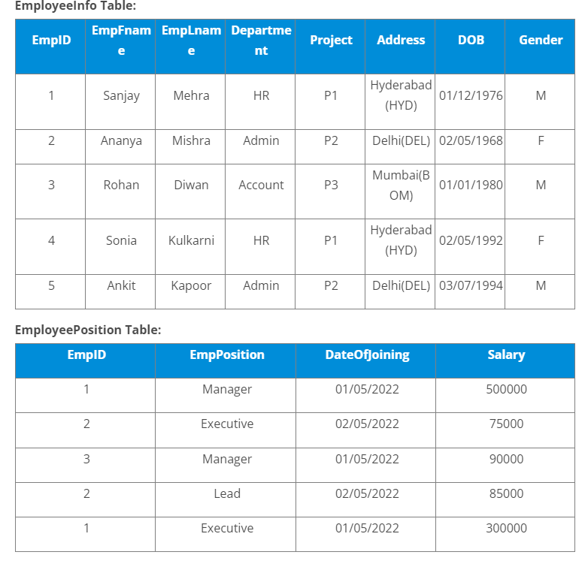

**Q1)Write a query to fetch the EmpFname from the EmployeeInfo table in the upper case and use the ALIAS name as EmpName.**

**Answer-** SELECT UPPER(EmpFname) AS EmpName

FROM employeeinfo

**Q2)Write a query to fetch the number of employees working in the department ‘HR’.**

**Answer-** SELECT COUNT(*) AS NumEmployees

FROM EmployeeInfo

WHERE Department = 'HR'

**Q3)Write a query to get the current date.**

**Answer-** SELECT GETDATE() AS CurrentDate

**Q4)Write a query to retrieve the first four characters of EmpLname from the EmployeeInfo table.**

**Answer-** SELECT LEFT(EmpLname, 4) AS FirstFourChars

FROM EmployeeInfo

**Q5)Write a query to fetch only the place name(string before brackets) from the Address column of EmployeeInfo table.**

**Answer-** SELECT

SUBSTRING(Address, 1, CHARINDEX('(', Address) - 2) AS PlaceName

FROM

EmployeeInfo

**Q6)Write a query to create a new table that consists of data and structure copied from the other table.**

**Answer-** CREATE TABLE NewTable AS

SELECT * FROM employeeinfo

**Q7)Write q query to find all the employees whose salary is between 50000 to 100000.**

**Answer-** SELECT *

FROM EmployeePosition

WHERE Salary BETWEEN 50000 AND 100000

**Q8)Write a query to find the names of employees that begin with ‘S’**

**Answer-**

SELECT *

FROM employeeinfo

WHERE EmpFname LIKE 'S%'

**Q9)Write a query to fetch top N records.**

**Answer-** SELECT TOP N *

FROM EmmployeeInfo

**Q10)Write a query to retrieve the EmpFname and EmpLname in a single column as “FullName”. The first name and the last name must be separated with space.**

**Answer-** SELECT EmpFname + ' ' + EmpLname AS FullName

FROM employeeinfo

### ****Q11. Write a query find number of employees whose DOB is between 02/05/1970 to 31/12/1975 and are grouped according to gender****

**Answer-** SELECT Gender, COUNT(*) AS NumEmployees

FROM employeeinfo

WHERE DOB BETWEEN '1970-05-02' AND '1975-12-31'

GROUP BY Gender

### ****Q12. Write a query to fetch all the records from the EmployeeInfo table ordered by EmpLname in descending order and Department in the ascending order.****

Answer-

SELECT *

FROM employeeinfo

ORDER BY EmpLname DESC, Department ASC

### ****Q13. Write a query to fetch details of employees whose EmpLname ends with an alphabet ‘A’ and contains five alphabets.****

Answer- SELECT *

FROM employeeinfo

WHERE EmpLname LIKE '____A'

### ****Q14. Write a query to fetch details of all employees excluding the employees with first names, “Sanjay” and “Sonia” from the EmployeeInfo table.****

Answer-

SELECT *

FROM employeeinfo

WHERE EmpFname NOT IN ('Sanjay', 'Sonia')

### ****Q15. Write a query to fetch details of employees with the address as “DELHI(DEL)”.****

Answer- SELECT *

FROM EmployeeInfo_

WHERE Address = 'DELHI(DEL)'

### ****Q16. Write a query to fetch all employees who also hold the managerial position.****

Answer- SELECT e.*

FROM EmployeeInfo e

INNER JOIN EmployeeInfo m ON e.ManagerId = m.EmpId;

### ****Q17.**** Write a query to fetch the department-wise count of employees sorted by department’s count in ascending order.

Answer- SELECT employeeinfo.*

FROM EmployeePosition

INNER JOIN employeeinfo ON employeeinfo.Empid = EmployeePosition.EmpId

### ****Q18. Write a query to calculate the even and odd records from a table.****

**Answer-** SELECT *

FROM employeeinfo

WHERE RowNum % 2 = 0

SELECT *

FROM employeeinfo

WHERE RowNumber % 2 <> 0

### ****Q19.**** Write a SQL query to retrieve employee details from EmployeeInfo table who have a date of joining in the EmployeePosition table.

Answer-

SELECT *

FROM employeeinfo

WHERE EmpId IN (

SELECT EmpId

FROM EmployeePosition)

### ****Q20. Write a query to retrieve two minimum and maximum salaries from the EmployeePosition table.****

Answer- SELECT Salary

FROM EmployeePosition

ORDER BY Salary ASC

SELECT Salary

FROM EmployeePosition

ORDER BY Salary DESC

### ****Q21.**** Write a query to find the Nth highest salary from the table without using TOP/limit keyword.

Answer- SELECT Salary

FROM (

SELECT Salary, ROW_NUMBER() OVER (ORDER BY Salary DESC) AS RowNum

FROM EmployeePosition

) AS RankedSalaries

WHERE RowNum =9

### ****Q22. Write a query to retrieve duplicate records from a table.****

Answer- SELECT *

FROM EmployeePosition

GROUP BY EmpId, EmpPosition

HAVING COUNT(*) > 1

### ****Q23. Write a query to retrieve the list of employees working in the same department.****

Answer- SELECT Department, GROUP_CONCAT(EmpId ORDER BY EmpId) AS EmployeeIds

FROM EmployeeInfo

GROUP BY Department

HAVING COUNT(*) > 1

### ****Q24. Write a query to retrieve the last 3 records from the EmployeeInfo table.****

Answer SELECT *

FROM EmployeeInfo

ORDER BY EmpId DESC

LIMIT 3 OFFSET 2;

### ****Q25. Write a query to find the third-highest salary from the EmpPosition table.****

**Answer-** SELECT Salary

FROM (

SELECT Salary, ROW_NUMBER() OVER (ORDER BY Salary DESC) AS RowNum

FROM EmployeePosition

) AS RankedSalaries

WHERE RowNum = 3

### ****Q26. Write a query to display the first and the last record from the EmployeeInfo table.****

Answer- -- Displaying the first record

SELECT *

FROM employeeinfo

ORDER BY EmpId ASC

-- Displaying the last record

SELECT *

FROM EmployeeInfo

ORDER BY EmpId DESC

### ****Q27. Write a query to add email validation to your database****

Answer- ALTER TABLE EmployeeInfo

ADD CONSTRAINT chk_email CHECK (email LIKE '%@%.%')

### ****Q28. Write a query to retrieve Departments who have less than 2 employees working in it.****

Answer-

SELECT Department

FROM employeeinfo

GROUP BY Department

HAVING COUNT(*) < 2

### ****Q29. Write a query to retrieve EmpPostion along with total salaries paid for each of them****

Answer- SELECT EmpPosition, SUM(Salary) AS TotalSalaries

FROM EmployeePosition

GROUP BY EmpPosition

### ****Q30. Write a query to fetch 50% records from the EmployeeInfo table.****

Answer- SELECT *

FROM EmployeeInfo

LIMIT (SELECT CEIL(COUNT(*) * 0.5) FROM EmployeeInfo)

